Written / read research:
https://aht.ca/wp-content/uploads/2017/12/Lodge.pdf
https://en.wikipedia.org/wiki/Sweat_lodge
Old diagram:
https://religionsmn.carleton.edu/items/show/4988

Images used for project construction:

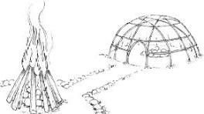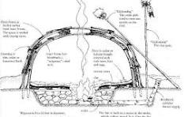
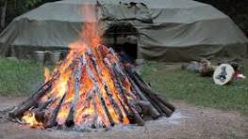 Etc.

Project Images:
